**Color capture (Get hex code for color)**

1. <https://www.rgbtohex.net/> (Using RGB to get color code)

View the color code in Adobe of RGB value and then use the web link to get the Hex color code.

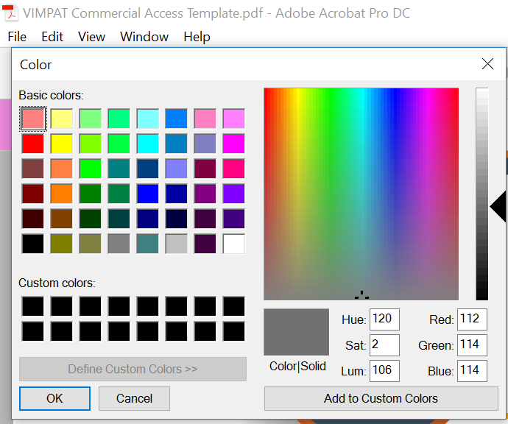

1. <https://html-color-codes.info/colors-from-image/> (Uploading image to get color code)